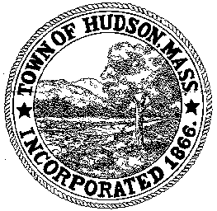

CONSERVATION COMMISSION
78 Main Street, Hudson, MA 01749
(978) 562-2020

Leif Longtine, Chairman David Esteves, Vice Chairman Paul Byrne, Member

David Mercer, Member Joseph Rodrigues, Member Al Tashian, Member W. Minot Wood, Member

Meeting Agenda
August 15, 2013
7:00 P.M.

- Preliminaries
  - Open Meeting
  - Roll Call

2.0 New Business
3.0 Old Business
4.0 Correspondence
5.0 Adjournment

Next Meeting is September 5, 2013

